Data Handling and Visualization (DSA06)
Name: Prasanna M Reg. No: 1925260244
Set 18: Product Inventory Management
Question 1. Create a bar chart to visualize the quantity of each product in the inventory. Label the axes and title the chart.
Program (R):
library(ggplot2)
inv <- data.frame(Product_ID = 1:3, Product_Name = c("Product A","Product B","Product C"),
Quantity = c(250,175,300), Price = c(20,15,18))
ggplot(inv, aes(x = Product_Name, y = Quantity)) +
geom_col(fill = "steelblue", colour = "black", width = 0.6) +
geom_text(aes(label = Quantity), vjust = -0.3) +
labs(title = "Quantity Available by Product", x = "Product", y = "Quantity Available") +
theme_minimal()
Output:
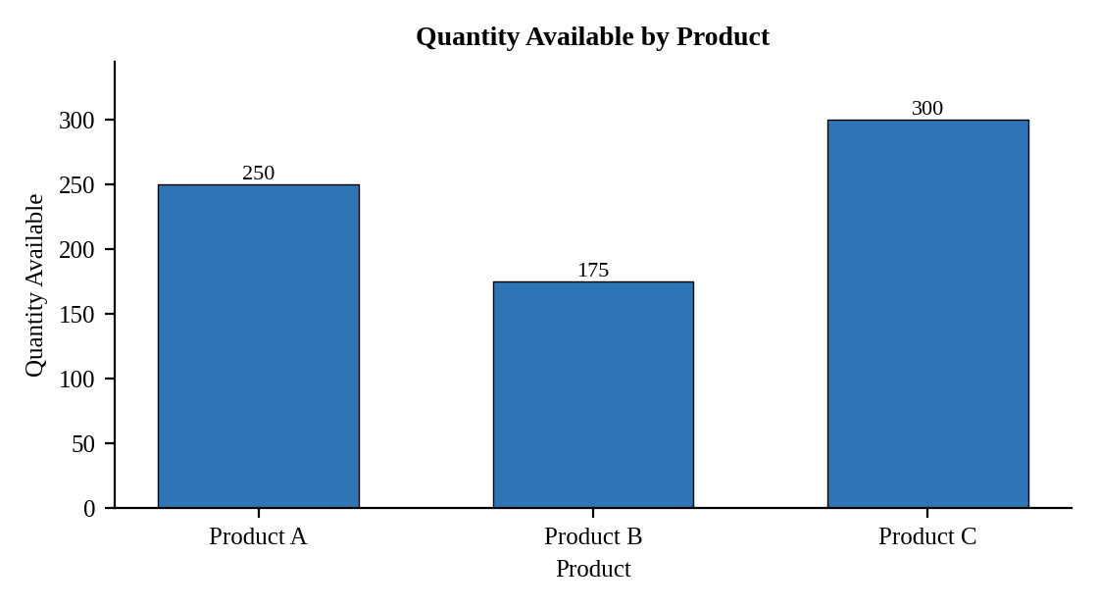
Interpretation:
Product C has the largest stock (300 units) and Product B the smallest (175 units). Product B is the first to need restocking.

Question 2. Generate a stacked bar chart to show the quantity of each product within different product categories.
Assumed data: No category data is given, so each product is split into two sample categories (Electronics and Accessories) that add up to its total quantity.
Program (R):
inv_cat <- data.frame(
Product = rep(c("Product A","Product B","Product C"), each = 2),
Category = rep(c("Electronics","Accessories"), times = 3),
Quantity = c(150,100, 75,100, 200,100))
ggplot(inv_cat, aes(x = Product, y = Quantity, fill = Category)) +
geom_col(position = "stack", colour = "black") +
geom_text(aes(label = Quantity), position = position_stack(vjust = 0.5)) +
labs(title = "Quantity by Product and Category", x = "Product", y = "Quantity Available") +
theme_minimal()
Output:
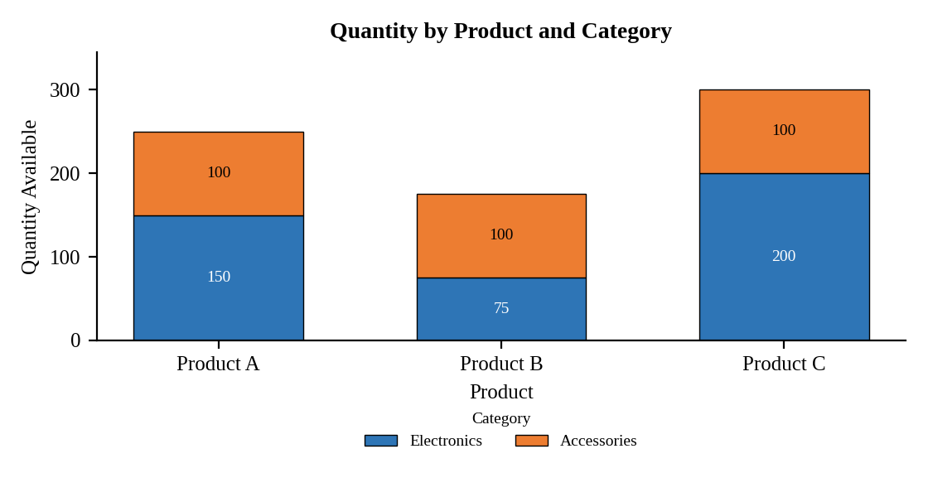
Interpretation:
Electronics make up most of the stock of Products A and C (60% and 67%), whereas Product B holds more Accessories (100) than Electronics (75). Accessories stock is the same (100 units) for all three products.

Question 3. Build a table to show the inventory data for each product. Label the table elements.
Program (R):
inv$Stock_Value <- inv$Quantity * inv$Price
library(knitr)
kable(inv, align = "c",
col.names = c("Product ID","Product Name","Quantity Available","Price ($)","Stock Value ($)"),
caption = "Table 18.1: Product Inventory Data")
Output:
Table 18.1: Product Inventory Data
Product ID | Product Name | Quantity Available | Price ($) | Stock Value ($)
1 | Product A | 250 | 20 | 5000
2 | Product B | 175 | 15 | 2625
3 | Product C | 300 | 18 | 5400

Interpretation:
The inventory holds 725 units worth 13025 dollars in total. Product C carries the highest stock value (5400), followed by Product A (5000) and Product B (2625).

Question 4. Develop a Tableau dashboard combining the bar chart, stacked bar chart, and the table for interactive exploration of inventory data.
Procedure (Tableau):
1. Open Tableau, click Connect, choose Text file / Microsoft Excel, select "Product_Inventory.csv" and open Sheet 1.
2. Add a Category field to the data source (Electronics / Accessories) with the quantity split for each product.
3. Sheet 1 (Bar): Columns = Product Name; Rows = SUM(Quantity Available); add labels.
4. Sheet 2 (Stacked bar): Columns = Product Name; Rows = SUM(Quantity Available); Color = Category; add labels.
5. Sheet 3 (Table): Rows = Product Name; Columns = Measure Names; Text = Measure Values (Quantity, Price, Stock Value = Quantity * Price).
6. Click New Dashboard, name it "Inventory Dashboard", set Size to Automatic and drag the sheets onto the canvas (charts on top, table below).
7. Select each chart and click the "Use as Filter" icon so that clicking a bar or slice filters the other sheets; keep tooltips enabled.
8. Add a title to every sheet, adjust labels and colours, and save the workbook (File > Save As, .twbx).

Output:
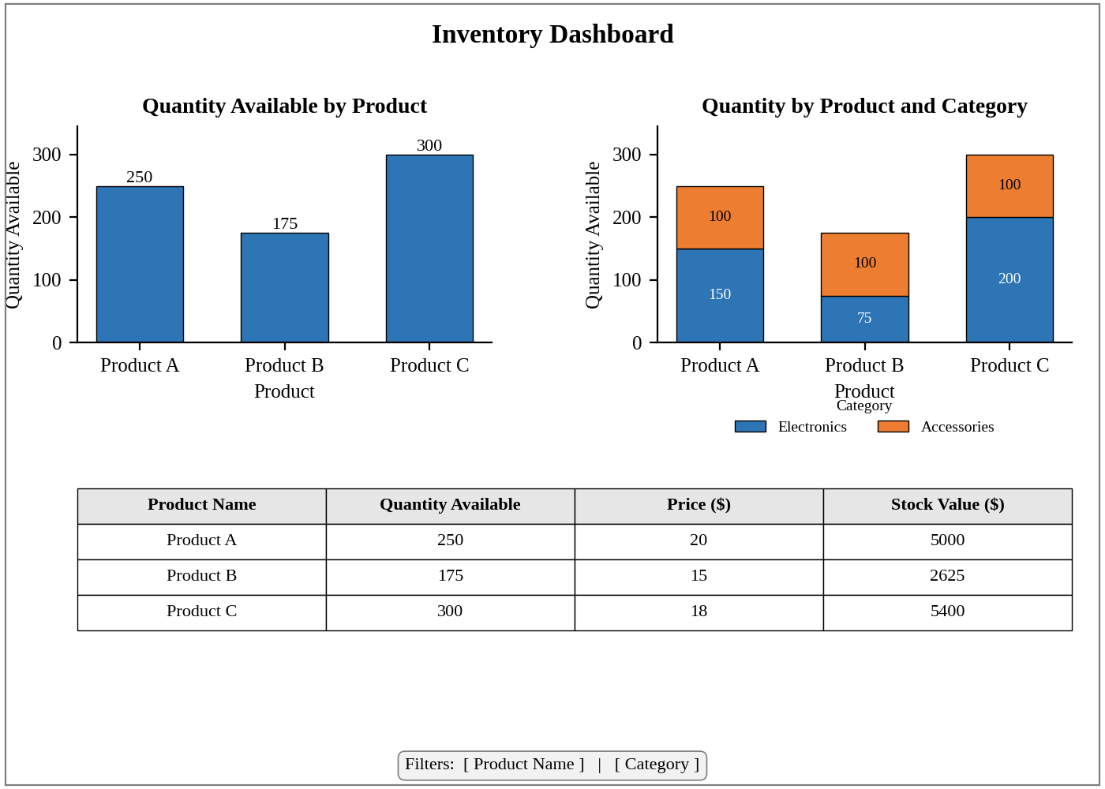
Dashboard layout (preview of the Tableau output).
Interpretation:
Filtering by category or product updates all three views. The dashboard helps a manager see which products hold the most stock and in which category.

